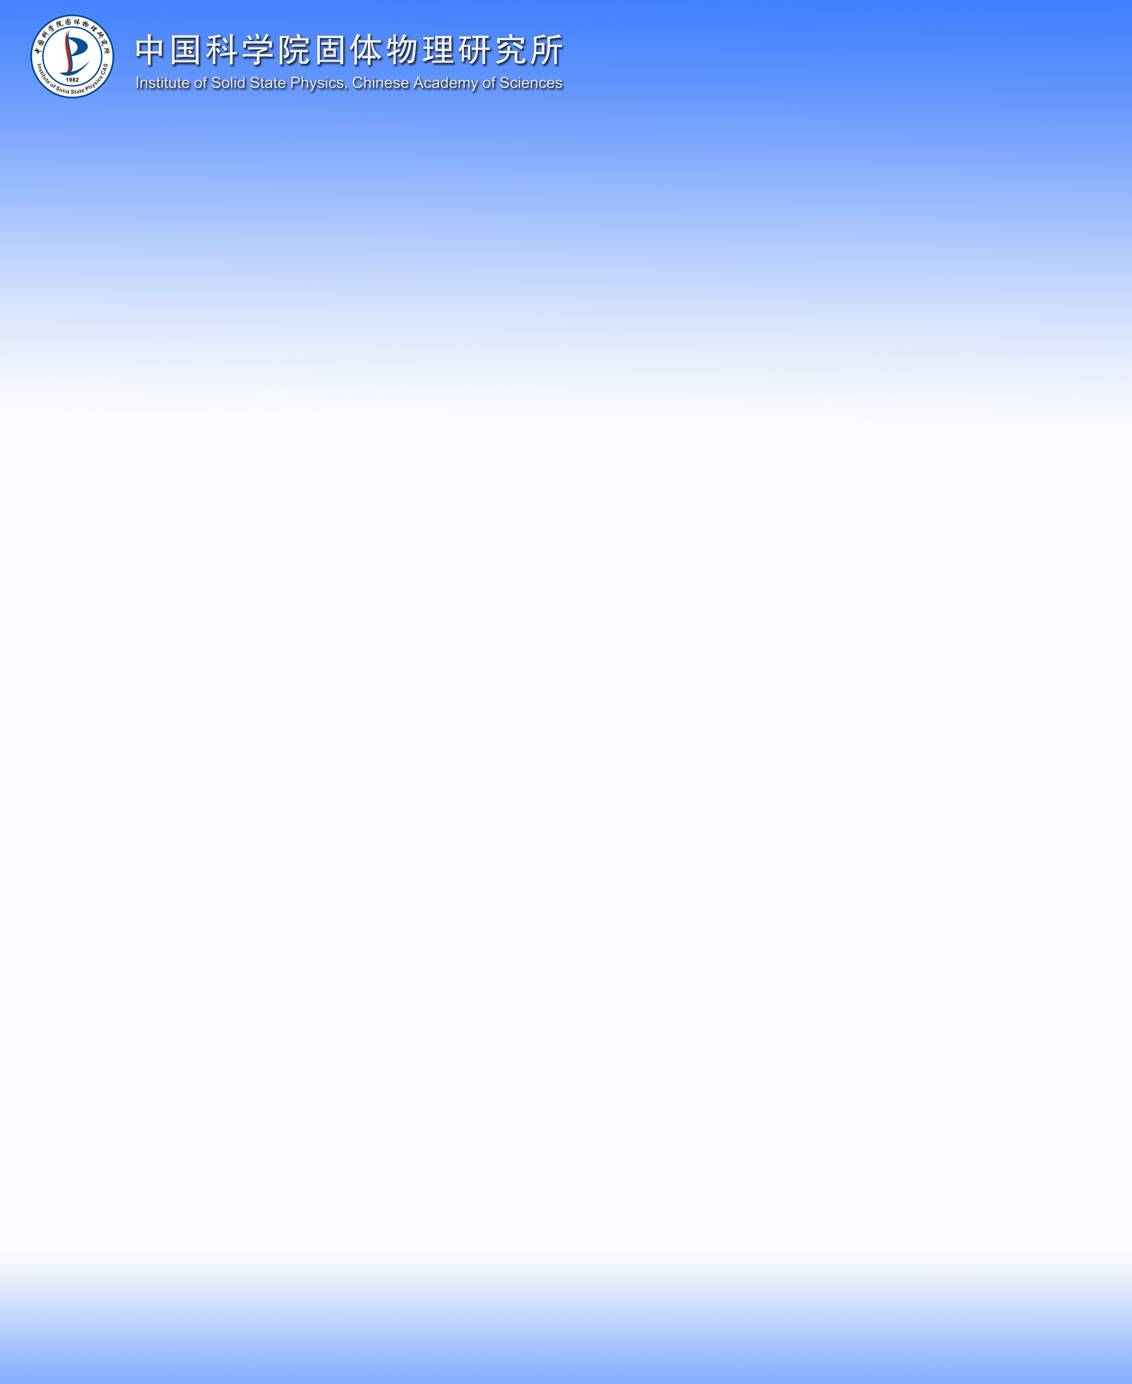

**报告题目：**

**Advanced Generation of Nanoparticles by Lasers in Liquids:   
Ligand-free, monodisperse colloids   
in energy application and biomedical research**

**报 告 人：**

**Prof. Dr.-Ing. Stephan Barcikowski**

Chair of Technical Chemistry I, University of Duisburg-Essen and Center for Nanointegration Duisburg-Essen (CENiDE), Universitaetsstr. 7, 45141 Essen

Tel : +49 (0)201 - 183 3150

Fax : +49 (0)201 - 183 3049

Internet: <http://www.uni-due.de/barcikowski/>

YouTube Channel: http://youtube.com/nanofunction

Email: [stephan.barcikowski@uni-due.de](mailto:stephan.barcikowski@uni-due.de)

**报告时间:** 2013年7月28日（星期日）上午10点

**报告地点:** 固体所大楼321会议室

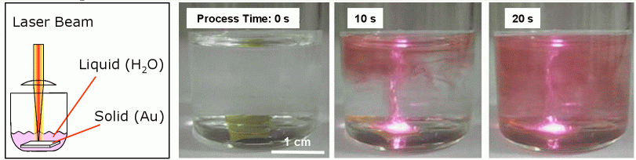**报告摘要:**

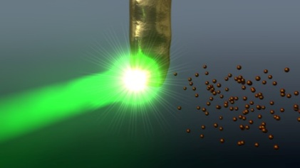Size matters. After decades of intensive nanoresearch, nanoparticles are widely implemented as functional elements on surfaces, into volumes and as nanohybrids, with application prospects as bioactive nanoparticle-polymer-composites and nanoparticle-bioconjugates. However, nowadays only a limited variety of materials that may be **integrated into advanced functional products** are available: Nanoparticles synthesized by conventional gas phase processes are often agglomerated to micropowders that are hardly re-dispersible into functional matrices, and chemical methods often lead to impurities of the nanoparticle colloids caused by additives and precursor reaction products. As alternative synthesis route, **laser ablation and nanoparticle generation in liquids** has proven its capability to generate and conjugate elemental, nanoalloy, semiconductor or ceramic nanoparticles.

Fabrication of nanoparticles using laser technology allows a rapid nanomaterial design enabling the manufacturing of catalyst materials, nanocomposites and nanobiomarkers:

* in contrary to dry nanopowders, nanoparticle colloids are not inhalable and thus lead to an improved occupational safety during product handling,
* chemical precursors are not required by this physical synthesis route and thus the aqueous colloids are 100 percent pure providing ligand-free nanoparticles,
* the ligand-free nanoparticles couple more efficiently to biomolecules and polymer matrices
* this method can be applied universally and in gram scale with almost unlimited variety of materials and solvents.

In this talk, examples of harvesting these unique properties in the field of **biomedicine and catalysis** are given.

**个人简介:**

Stephan Barcikowski studied chemistry in Braunschweig and Hannover, after which he worked for the industrial laser manufacturer Rofin-Sinar Laser AG and received his doctorate award in Mechanical Engineering. At Laser Zentrum Hannover e.V. (LZH), a private-non-profit research center, Barcikowski built up the Nanomaterials group and the research group “Nanoparticles” in the Cluster of Excellence “REBIRTH”, and led the institute’s Material Processing Department. In 2010, he funded a company and organized the 1st international conference on laser ablation in liquid ANGEL. In 2011, he accepted the call to the Chair of Technical Chemistry I at the University of Duisburg-Essen.

He received the “first prize for scientific work” by the Foundation of Industrial Research (StiftungIndustrieforschung). In2012, he has been nominated for the Berthold Leibinger Innovation Award and in 2013, he received the Faculties’ price for best teaching.

Stephan Barcikowski is working on applications of liquid-supported laser material processing in chemistry. His research fields reach from up-scaling process technology for laser-based nanomaterial synthesis to the functionalization of nanoparticles and nanocomposites for biotechnology, biomedicine and energy technology.

Prof. Barcikowski is Editor-in-Chief, of the Journal “BioNanoMaterials" (Reviewed, ISI-Indexed), and has served as Guest Editor for the Journal of Physical Chemistry Chemical Physics, ANGEL Themed Issue (11 articles, 115 pages), 2013, Vol. 15, 9, 3009-3114 as well as the Journal of Physical Chemistry, ANGEL Themed Issue (26 articles, 95 pages), 2011, Vol. 115, 12, 4985-5180.

He has more than 300 publications, including 85 reviewed papers and 14 patent applications.

**联 系 人：梁长浩**

**联系方式：13085055265**